Example13:
Write a python program to create a GUI window with Radio Buttons?
demo.py
from tkinter import *
from tkinter import messagebox
window=Tk()
window.geometry("800x400")
window.resizable(0,0)
window.title("Vagdevi Technologies")
window.iconbitmap("pytlogo.ico")
window['bg']="red"

#variable Decleration
gender=StringVar()
gender.set("ot")

#functions/actions
def get_gender():
val=gender.get()
if val=="m":
msg=f"you are male"
elif val=="f":
msg=f"you are female"
else:
msg=f"Gender Not Specified"

messagebox.showinfo("Result",msg)

def reset():
gender.set("ot")

def close():
window.destroy()

#welcome label
L=Label(window,text="Welcome to Vagdevi Technologies",fg="yellow",bg="red",
font="arial 15 bold")
L.pack(padx=10,pady=20)

#label with entry field
L1=Label(window,text="Select Your Gender:",bg="red",fg="blue",
font="elephant 15 italic")
L1.place(x=50,y=100)
#Radio buttons
R1=Radiobutton(window,text="Male",variable=gender,value="m",fg="blue",bg="red",
font="arial 15 bold")
R1.place(x=350,y=100)
R2=Radiobutton(window,text="Female",variable=gender,value="f",fg="blue",bg="red",
font="arial 15 bold")
R2.place(x=450,y=100)
R3=Radiobutton(window,text="Others",variable=gender,value="ot",fg="blue",bg="red",
font="arial 15 bold")
R3.place(x=550,y=100)
#buttons(actions)
B1=Button(window,text="GetGender",bg="yellow",fg="red",font="roman 15 bold",
command=get_gender)
B1.place(x=200,y=200)
B2=Button(window,text="Clear",bg="yellow",fg="red",font="roman 15 bold",
command=reset)
B2.place(x=400,y=200)
B3=Button(window,text="Close",bg="yellow",fg="red",font="roman 15 bold",
command=close)
B3.place(x=550,y=200)
window.mainloop()
output
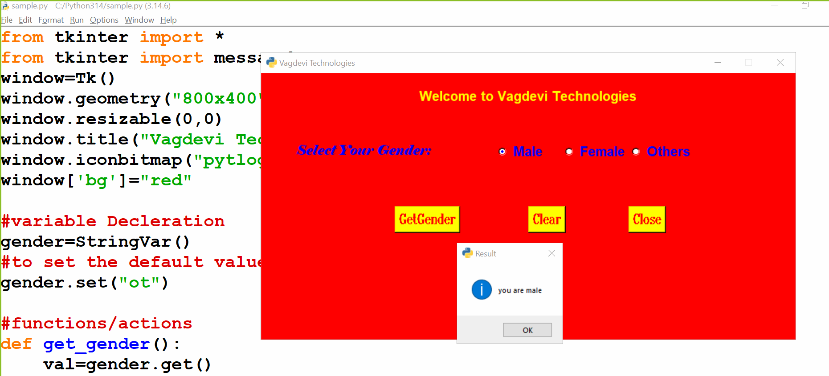
Example14:
Write a python script/program to create a GUI window with check-buttons?
demo.py
from tkinter import *
from tkinter import messagebox
window=Tk()
window.geometry("800x400")
window.resizable(0,0)
window.title("Vagdevi Technologies")
window.iconbitmap("pytlogo.ico")
window['bg']="red"

#variable Decleration
course_1=IntVar()
course_2=IntVar()
course_3=IntVar()
course_4=IntVar()

#set the default values
course_1.set(0)
course_2.set(0)
course_3.set(0)
course_4.set(0)
#functions/actions
def get_courses():
courses=[]
if course_1.get()==1:
courses.append("Python")
if course_2.get()==1:
courses.append("Java")
if course_3.get()==1:
courses.append("Data Science")
if course_4.get()==1:
courses.append("SQL")
selected_courses=",".join(courses)
msg=f"Selected Courses are: {selected_courses}"
messagebox.showinfo("Result",msg)

def reset():
course_1.set(0)
course_2.set(0)
course_3.set(0)
course_4.set(0)

def close():
window.destroy()

#welcome label
L=Label(window,text="Welcome to Vagdevi Technologies",fg="yellow",bg="red",
font="arial 15 bold")
L.pack(padx=10,pady=20)

#label with entry field
L1=Label(window,text="Select Your Courses:",bg="red",fg="blue",
font="elephant 15 italic")
L1.place(x=50,y=100)

#Check buttons
C1=Checkbutton(window,text="Python",onvalue=1,offvalue=0,variable=course_1,
fg="blue",bg="red",font="arial 15 bold")
C1.place(x=300,y=100)
C2=Checkbutton(window,text="Java",onvalue=1,offvalue=0,variable=course_2,
fg="blue",bg="red",font="arial 15 bold")
C2.place(x=450,y=100)
C3=Checkbutton(window,text="Data Science",onvalue=1,offvalue=0,
variable=course_3,fg="blue",bg="red",font="arial 15 bold")
C3.place(x=300,y=150)
C4=Checkbutton(window,text="SQL",onvalue=1,offvalue=0,variable=course_4,
fg="blue",bg="red",font="arial 15 bold")
C4.place(x=450,y=150)

#buttons(actions)
B1=Button(window,text="GetCourses",bg="yellow",fg="red",font="roman 15 bold",
command=get_courses)
B1.place(x=200,y=200)
B2=Button(window,text="Clear",bg="yellow",fg="red",font="roman 15 bold",
command=reset)
B2.place(x=400,y=200)
B3=Button(window,text="Close",bg="yellow",fg="red",font="roman 15 bold",
command=close)
B3.place(x=550,y=200)
window.mainloop()
output
